Until Fr Athaide arrives St Mary’s masses will be covered by a number of ‘Supply priests’. We have a list to take us to 28th May.
Sunday May 21st Fr Jonathan Cotton
Wednesday May 24th Fr Robert
Thacker
Sunday May 28th Fr Alex Adkins

Faith and Footprint
Monday 5 June 7.00–8.30 p.m. on Zoom
Join Caritas on World Environment Day for our summer workshop to help you bring Laudato Si to life in your parish. You’ll find the workshop especially useful if you are involved in the CAFOD Livesimply scheme or a diocesan Pioneer Parish – but everyone who is praying and working for a greener Church and world is invited. Please see the poster in the Narthax for further information and how to sign up

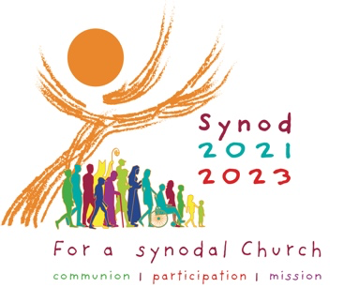
***********************************
Parish Hall Repairs
The kitchen is coming along really well and the fitter hopes to be finished next week, assuming that the plumber and electrician are able to get in promptly to do what’s required.

Diocesan Pilgrimage

Bishop Patrick will lead the Diocesan Pilgrimage to Walsingham on Saturday 17th June. Details on the poster in the Narthax.

SUNDAY 21st May 2023
7th Sunday of Easter

Sun 9.30am MASS:
Reader: Lesley Dover
Coffee: None

11.30am MASS in St Joseph’s, Mablethorpe

MONDAY St Rita

TUESDAY

WEDNESDAY
MASS: 10.00am
Reader: Pat Millican

THURSDAY St Bede

FRIDAY

SATURDAY St Augustine

8th Sunday of Easter Year A

Sun 9.30am MASS: For the Parish
Reader:
Coffee: None

11.30am MASS in St Joseph’s, Mablethorpe

Please remember in your prayers
those who are sick or housebound
Lea Small, Elizabeth Melling, Melanie Tiernan,
Shirley Kirkham, Paddy Shillington, Ann Selby,
Margaret & Robert Gwynne, Kevin Keeley,
Mary & Roger Norburn, Peter Endean, Anthony
McCarthy, Jim Ellison, Judith Brook,
Sister Joseph (Edith Appleby), Sally
Shillington, Catherine Keeley, Pam Stephens
and Fr Adrian Convery

Anniversaries this week

Delabene Marsden, Bernard Zakary, Henry
Trimlett, Mona Charlton and Mary Younger.
St Mary’s DIARY & NOTEPAD 21st May 2023
69 Upgate, Louth, Lincolnshire LN11 9HD Website: www.holytrinitygci.uk
Tel: 01472 342301 Mobile: 07943 059747 email: office@holytrinitygci.uk

Tel: 01472 342301 Mobile 07943 059747 email: office@holytrinitygci.uk

Retiring Collection:
NONE

Collections last Sunday
_{NRCDT A Registered Charity}
_{Envelopes:} _{£65.00}
_{Loose plate:} _{£146.00}
Candles £60.00
_{Booklet} _{£5.00}

Weekly bills based on annual totals:
Diocesan Quota: £106.00
Utilities: £120.00
Insurance: £30.00
Housekeeping: £29.00

Loose plate

