Mass on Sunday May 28th Fr Alex Adkins
Wednesday May 31st Fr Robert
Thacker
Thank you to all the priests who have ensured that we have been able to attend Mass during this period when we have been without a Parish Priest. Fr Athaide intends to keep the Mass times as they are for the first month while he settles in.

Faith and Footprint
Join Caritas on Monday 5 June, World Environment Day, 7.00–8.30 p.m. on Zoom for our summer workshop to help you bring Laudato Si to life in your parish. Please see the poster in the Narthax for further information and how to sign up.
Sunday Lunch
Siobhan Norton is organising a Sunday Lunch at the Miller’s Daughter on 11th June, price £11.45. Further details on the Notice Board in the Narthax; please add your names to the list and pay a deposit of £5 to Siobhan as soon as possible.
Siobhan’s number is: 07719995161

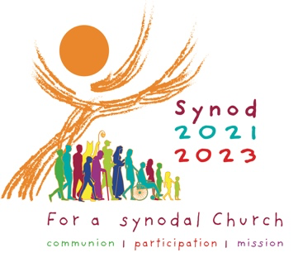
***********************************
Parish Hall Repairs
I have been away this week, but hopefully the kitchen is finished and we will be able to start coffee again from next week.
Diocesan Pilgrimage
Bishop Patrick will lead the Diocesan Pilgrimage to Walsingham on Saturday 17th June. Details on the poster in the Narthax.
Rosary
Rosary on the first Saturday of the month will restart next Saturday 3rd June at 10.00am All welcome.
SUNDAY 28th May 2023
Pentecost Sunday

Sun 9.30am MASS:
Reader: Miranda Boon
Coffee: None

11.30am MASS in St Joseph’s, Mablethorpe

MONDAY Mary, Mother of the Church

TUESDAY

WEDNESDAY
MASS: 10.00am
Reader: Christina Myers

THURSDAY

FRIDAY

SATURDAY
10.00am Rosary
Sunday 4th June Holy Trinity Year A

Sun 9.30am MASS: For the Parish
Reader: Anne Dickinson
Coffee: Mira Boon and Lesley Dover

11.30am MASS in St Joseph’s, Mablethorpe

Please remember in your prayers
those who are sick or housebound
Lea Small, Elizabeth Melling, Melanie Tiernan,
Shirley Kirkham, Paddy Shillington, Ann Selby,
Margaret & Robert Gwynne, Kevin Keeley,
Mary & Roger Norburn, Peter Endean, Anthony
McCarthy, Jim Ellison, Judith Brook,
Sister Joseph (Edith Appleby), Sally
Shillington, Catherine Keeley, Pam Stephens
and Fr Adrian Convery.

Recently Died
Marian Land, who used to be a member of this Parish, died suddenly on 18th May. Please remember her, Martin, her husband and all the family in your prayers.

Anniversaries this week

Patrick Foley, Ivy McManus, Peter Oke and Canon Paul Klee.

St Mary’s DIARY & NOTEPAD 28th May 2023
69 Upgate, Louth, Lincolnshire LN11 9HD Website: www.holytrinitygci.uk
Tel: 01472 342301 Mobile: 07943 059747 email: office@holytrinitygci.uk

Tel: 01472 342301 Mobile 07943 059747 email: office@holytrinitygci.uk

Retiring Collection:
NONE

Collections last Sunday
_{NRCDT A Registered Charity}
_{Envelopes:} £
_{Loose plate:} £

Weekly bills based on annual totals:
Diocesan Quota: £106.00
Utilities: £120.00
Insurance: £30.00
Housekeeping: £29.00

Loose plate

